First of its kind stem cell therapy successful in China
Poorva Chavan Jan 19, 2015 at 10:31 am
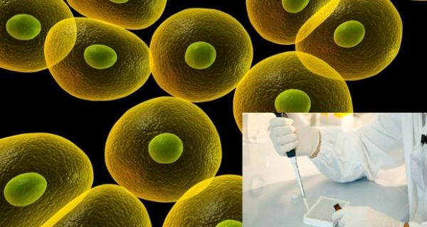
Raising the hopes of many paralysed people all across the world, a ground breaking spinal cord surgery was carried out in China. Spinal cord injuries are known to be one of the most challenging surgeries. Chinese scientists and doctors began a landmark clinical trial using a collagen complex and stem cells to repair damaged human spinal cord.
The surgery was carried out on a man whose lower body was paralysed after he met with an accident. The surgery went on for four hours. The regenerative stem cell treatment has been studied for around 10 years by Chinese scientists and this procedure was first of its kind and an advancement in the techniques of spinal cord treatment worldwide.(Read: First stem cell research paves way for new treatments for bipolar disorder)
The patient was implanted with mesenchymal stem cells and a collagen complex made up of collagen scaffold fibers, also described as collagen tubes, with collagen binding brain-derived neurotrophic factor (BDNF), a protein to support and encourage the growth of neurons, Dai was quoted by state-run Xinhua news agency.
‘Spinal nerves are like a cable. So we’ve designed collagenous fibers, like a bridge or a rail, that nerves can crawl along as they grow. Stem cells can produce regenerative tissue elements, so they improve the regeneration capacity of the wounded area,’ said Dai Jianwu, research fellow at Inst. of Genetics & Dev’t, CAS. (Read: Japan to start clinical tests to regenerate spinal cord)
Major spinal injuries nearly always lead to paralysis below the level of the injury. Doctors and scientists around the world have for years been trying to find new ways to treat the problem.Stem celll research began 10 years ago The Institute of Genetics and Development at the Chinese Academy of Sciences. At first the experiments were carried out on animal models which progressed from mice to bigger animals like dogs. The success of the experiments gave scientists more confidence to attempt the surgery on humans.
The four hour surgery was carried out on Friday went smoothly. The patients family now, can only wait and hope for the best. Six patients have signed up for the trial and the first surgery was completed on Friday, said a statement from the Chinese Academy of Sciences (CAS) said.

